FOND DU LAC CORVETTE CLUB
P.O. BOX 1551
FOND DU LAC, WI 54936-1551
ESTABLISHED 1974 www.fonddevettes.com
All business meetings will be held at American Legion, 500 Fond du Lac Ave, Fond du Lac on the third Wednesday of each month at 7:00 p.m. unless otherwise indicated in the newsletter.
Food pantry donations: please bring one or two nonperishable items to each club meeting.
OFFICERS FOR 2024:
PRESIDENT - JIM WOLFE 920-579-0709 VICE-PRESIDENT – LISA PATTERSON
TREASURER - PAT SCHNETTLER 920-960-9873 GOVERNOR - DOUG JARVIS 920-921-5890
SECRETARY – LINDA VEDA 414-750-8190
AMBASSADOR - ED FOY 920-922-8928

STEERINGCOMMITTEE
TODD & JODI BEYER - 920-929-9297, ED & JUDY FOY - 920-922-8928, TIM & LAURIE KRAWCZYK - 920-923-4347,
RON & SANDY DAVIS - 920-960-5847, DOUG & KAREN JARVIS - 920-921-5890, KEVIN & KARI SCHNEIDER -
920-517-2980, PAUL LAND - 920-251-0390, JEFF & KATIE HELLER - 920-915-7524,
JIM & PAT SCHNETTLER 920-960-9873 DAVE & AMY EWALD - 920 252-3225, CHUCK MAHNKE - 920-933-2119, JIM & CAHTY WOLFE – 920-579-0709

SUNSHINECOMMITTEE
JAN ADELMAN / jaad77@gmail.com
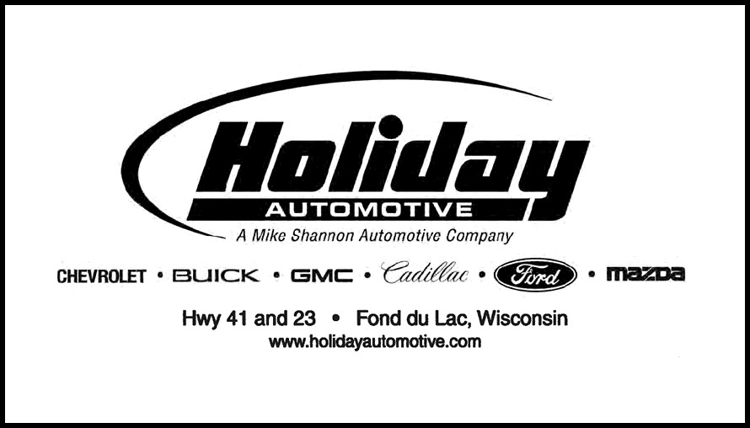

December 20, 2023
Club President Jim Wolfe called the meeting to order at 7:27PM.
Members present-27
Guests-0
New Members – Gary & Barb Hensel, 2006 Convertible
New Cars-0

GOVERNOR’S REPORT - Doug Jarvis - no news to report.
TREASURER’S REPORT
Pat Schnettler reported on the finances of the Club and they were approved.
Dues for 2024 are to be paid by the end of December. If you have not yet paid, please get a check in the mail ASAP.

NATIONAL CORVETTE MUSEUM
Ed Foy reported that registration is now open for the National Corvette Caravan on Labor Day Weekend to Bowling Green, KY. If you contact the museum they will give you information on the caravan. January through March the museum will be closed on Tuesdays. Due to manufacturing advancement the plant will be closed to tours as of February 5, 2024.
ROAD AMERICA
The Paddock Shop is open until 3pm through Christmas. The Paddock Shop has a new Road America sign for sale.

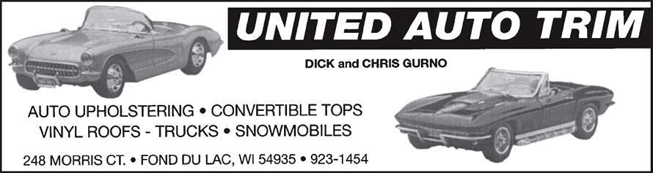
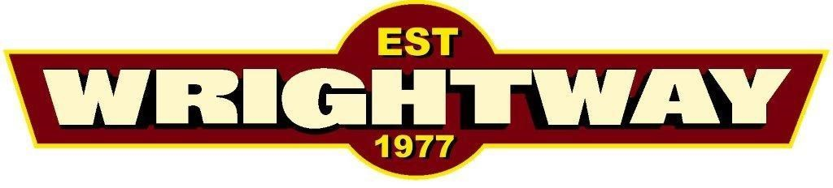
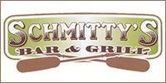

STEERING COMMITTEE, OFFICERS AND SUNSHINE COMMITTEE REPORT
The Sunshine Committee: If you are aware of a member that may have an upcoming surgery, is under the weather, or just in need of some sunshine, please contact Jan Adelman so she can reach out to them on behalf of the Club.
Jim Schnettler was at the meeting and doing well with his new shoulder.

Club Steering Committee:
A meeting was held after the regular meeting to start organizing for 2024.
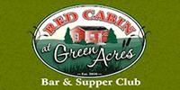

OLD BUSINESS:
Salvation Army Bell Ringers from our club numbered 14 which was a good turnout! After bell ringing we met at Backyard Bar and Grill for dinner and great conversations.
The Herd Basketball Game event had to be cancelled as we needed 12 people to attend to receive a group rate for the tickets.
2023 Christmas Party: 51 people have signed up to attend. It is being held at Avenue 795, with cocktails at 5:30 and dinner at 6:00pm. The cost is $10 per person. FYI, this restaurant has a new kitchen manager (Don Simonson’s daughter) and the reviews are excellent!
Thank you! Goes to Kari and Kevin Schneider for delivering the chicken to our Pot Luck tonight.

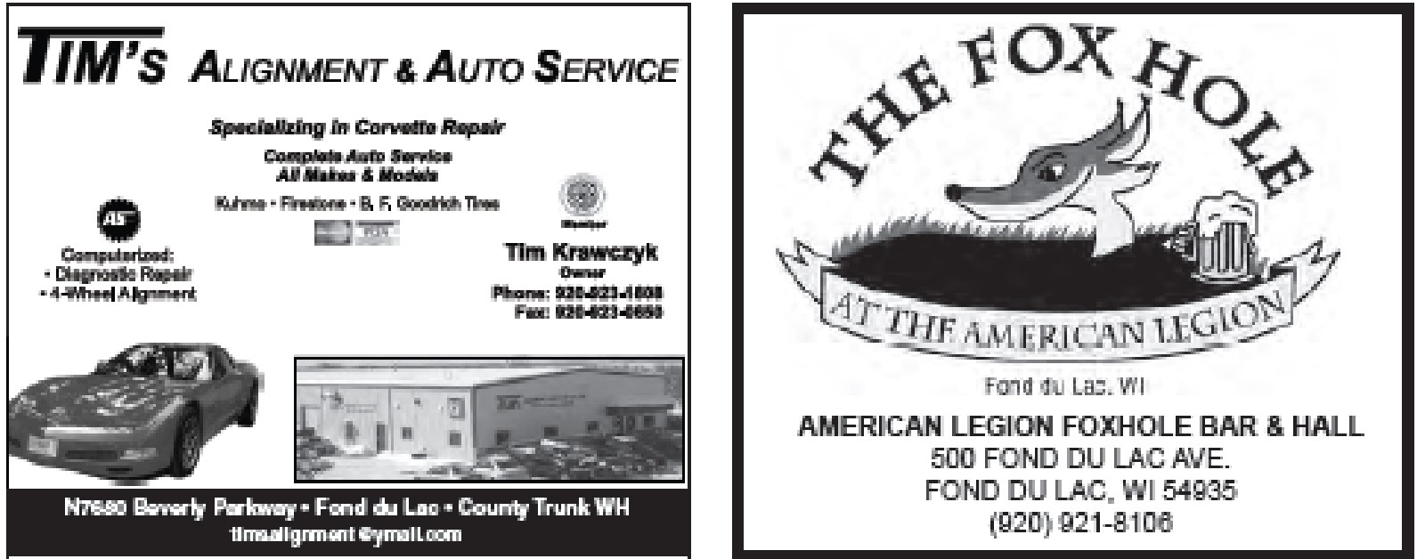
NEW BUSINESS:
*Christmas Party will be January 13, 2024 at Avenue 795 (formerly known as the KC Hall). Cocktails at 5:30. Dinner at 6:00 PM. Doug and Karen Jarvis are hosting. Thank you, Doug and Karen!

Doug and Karen Jarvis
920-921-5890

A thank you note was received from the Solution Center and was circulated to those present to read.
A sign-up sheet was passed out for the upcoming year to start scheduling events for our members to attend. We need volunteers to host rides, help with our annual Trip Around the Lake, suggest and plan new events for us to enjoy with our beautiful Corvettes. Please contact Jim Wolfe if you have any suggestions, questions or to volunteer. 920-579-0709.
John asked, should you start your Corvette once a week during winter months? There were a few opinions on this subject. Members have done it both ways, starting and not starting during storage, with no issues either way.
Ed Foy suggested a Get Your Car Out Ride to the Automobile Gallery in Green Bay. The Automobile Gallery has increased in size considerably since our last visit. After the gallery enjoy a good meal with good friends. Ed also offered to organize the cruise and it will be Saturday May 4th or Saturday May 11, 2024.
Ed also brought posters from his collection that he is giving to new homes.
Greg Dauterman reported that there is a Top Fuel Dragster in the lobby at Metalcraft of Mayville. If anyone is interested in looking at it Metalcraft is on the corner of County Road V and Slag Road in Mayville.
Bob Veda asked, who are the sponsors for our club? Needs to know when requesting
donations In April or May.

DECEMBER BIRTHDAYS DECEMBER ANNIVERSARIES
01 XAVIER MEILHON
10 RON DAVIS
11 KATHY HOERTH
17 PETER GIESE
22 DENISE STOFFEL

Meeting adjourned with motions by Sandy Davis and Judy Foy at 8:03pm

Respectfully Submitted
Linda Veda
